**Data Visualization of Wine Quality**

**Name:** N.Arshad

**Student ID:** 23033773

**Github:**

[**https://github.com/nomi522/Visualization**](https://github.com/nomi522/Visualization)

**Dataset:**

[**https://www.kaggle.com/datasets/yasserh/wine-quality-dataset**](https://www.kaggle.com/datasets/yasserh/wine-quality-dataset)

**Report of Wine Quality Dataset:**

**Steps:**

First of all, import all libraries that is required to make visualization and loading the dataset.

Import the dataset into dataframe using panda’s library.

Handle the missing values we can do that by dropping null values or by replacing null values with the average values.

Print the summary description of dataset using data.describe()

Make Different visualizations form dataset to find out different results.

**Graphs:**

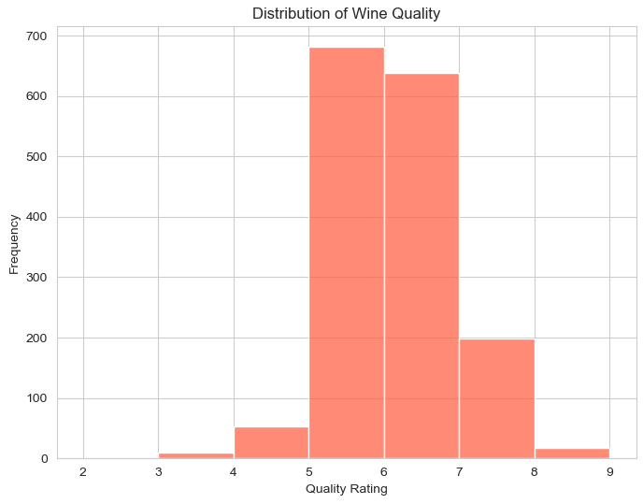

The labels Quality Rating and Frequency are on the x- and y-axes, respectively. The bars show that ratings of 5, 6, and 7 are the most frequently given, with 6 being the most common. 2, 3, 8, and 9 ratings are far less typical. Fewer wines are classified as high or poor grade, according to the graph, which shows that most wines are in the medium quality range.

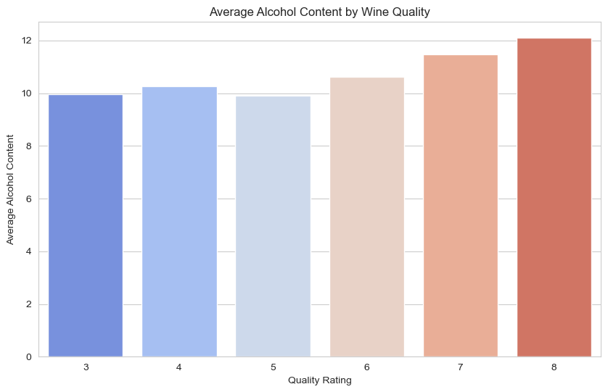

The average alcohol percentage of wines with a given quality rating is shown by each bar. This figure shows a general trend that a greater average alcohol content is correlated with higher quality ratings. The wines with the highest average alcohol content among the ratings displayed are those with a quality rating of 8, while those with a grade of 3 have a lower average alcohol content.

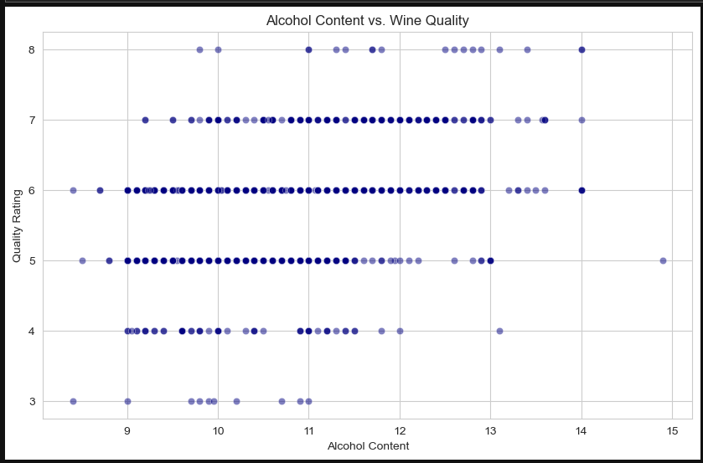

Every dot on the map symbolises a different wine, and its location is based on both its quality rating and alcohol concentration. Any potential relationship between the amount of alcohol in wine and its perceived quality is visualised using a plot.